Dessa Shapiro

Period 4 & 6

My first Connection

I am reading the book “*I Am Malala”* by Malala Yousafzal. This book is about Malala's life as a young girl in Swat, Pakistan. The book talks about the experiences that Malala had to suffer through when The Taliban(A radically militant Islamic movement)took control of Swat(a district in Malakand Division of Khyber Pakhtunkhwa province in Pakistan.) The Taliban came into Malala's life when she was around 10 years old. They started as a small organisation on the radio but rapidly grew. They started to become violent, and make insane rules. They banned girls from going to school and leaving their houses. They also banned technology and told people what jobs they could do and what jobs they couldn't. Malala’s father owned a school, so he believed that everyone had the right to an education. Malala grew up with the influence of her father's beliefs, later in life she took a lot of those beliefs with her.

Malala started talking out at events and important political meetings. One of these events was an interview and Malala stated “ ‘they cannot stop me. I will get my education if it’s at home,school or somewhere else. This is our request to the world - to save our schools, save our Pakistan,save our Swat.’ ” ( Pg. 161)

I feel that I can relate to this passage because I know that when I really love something I will always do anything to that thing no matter the risks. What Malala talks about is much more extreme because the thing that she loved was banned and it because dangerous to do that thing. Where I am from, there is no danger of the things I love being taken from me. I can still relate to Malala because I can imagine someone taking what I love away and I know that would be unbearable. When I was in 3rd grade my family decided to move to California. We wanted to look at possible areas to live in before we fully committed and moved. My whole family went to California together at first but there was too much ground to cover. So, my dad decided to go off on his own and look for places. I was young when he left and it was very hard for me. He had always been very close but now I would only see glimpses of him. I thought I had lost him. I think that you could apply this to what Malala is saying about thinking she lost the thing she loves.. I can better relate to the passage when I picture losing my family. I think I can relate this to my family more because I’m not particularly passionate about one certain thing, as Malala is about women's education. Overall Malala’s life is very different than mine and I hopefully won't ever experience what she had to go through. And I will never be able to totally empathize with her, but some aspects of our lives are similar.

**Song: Far away by carole king**

This song is about being away from the person you love.

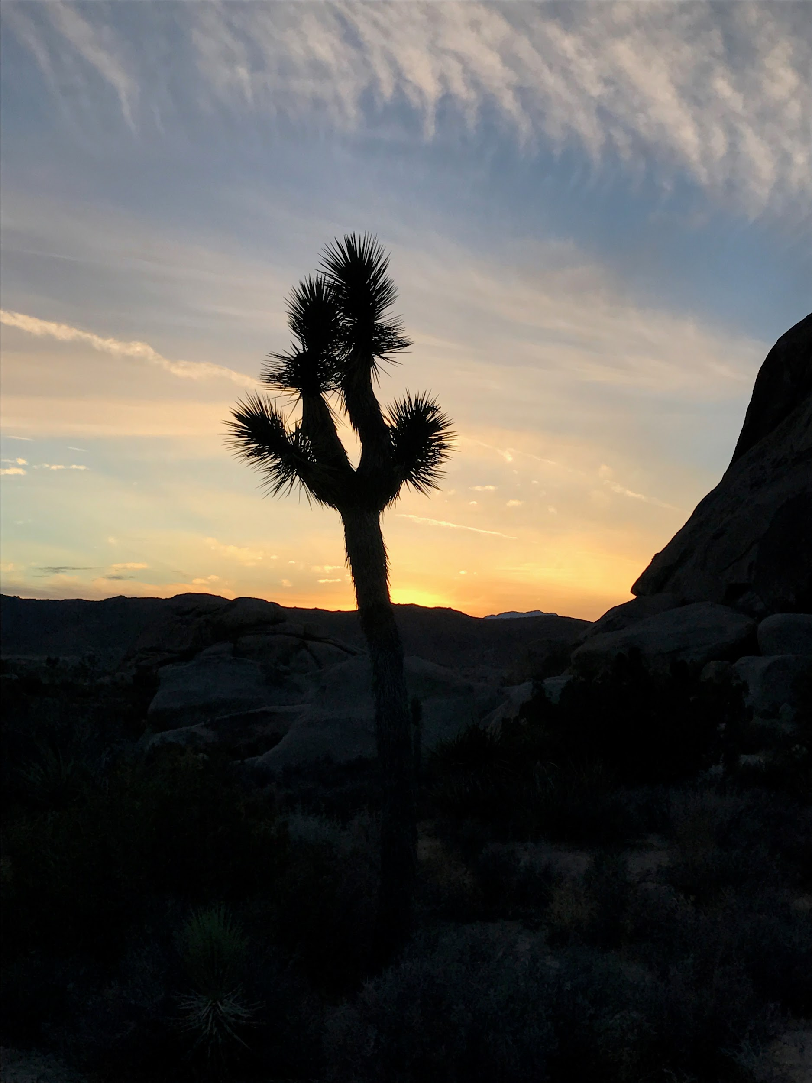

This one of the places me and my family visited when my dad was getting our belongings back in Colorado.